**FRUIT DISEASE DETECTION USING COLOR, TEXTURE ANALYSIS AND ANN**

**ABSTRACT:**

Now-a-days as there is prohibitive demand for agricultural industry, effective growth and improved yield of fruit is necessary and important. For this purpose farmers need manual monitoring of fruits from harvest till its progress period. But manual monitoring will not give satisfactory result all the times and they always need satisfactory advice from expert. So it requires proposing an efficient smart farming technique which will help for better yield and growth with less human efforts. We introduce a technique which will diagnose and classify external disease within fruits. Traditional system uses thousands of words which lead to boundary of language. Whereas system that we have come up with, uses image processing techniques for implementation as image is easy way for conveying. In the proposed work, OpenCV library is applied for implementation. K-means clustering method is applied for image segmentation, the images are catalogue and mapped to their respective disease categories on basis of four feature vectors color, morphology, texture and structure of hole on the fruit. The system uses two image databases, one for implementation of query images and the other for training of already stored disease images. Artificial Neural Network (ANN) concept is used for pattern matching and classification of diseases.

**Existing System:**

Now-a-days as there is prohibitive demand for agricultural industry, effective growth and improved yield of fruit is necessary and important. For this purpose farmers need manual monitoring of fruits from harvest till its progress period. But manual monitoring will not give satisfactory result all the times and they always need satisfactory advice from expert. So it requires proposing an efficient smart farming technique which will help for better yield and growth with less human efforts. We introduce a technique which will diagnose and classify external disease within fruits. Traditional system uses thousands of words which lead to boundary of language. Whereas system that we have come up with, uses image processing techniques for implementation as image is easy way for conveying.

**Disadvantages:**

* Difficult to detect diseases by human eyes.
* Delay in treating diseased fruit can cause it spread.
* Expensive to operate.

**Proposed system:**

In the proposed work, OpenCV library is applied for implementation. K-means clustering method is applied for image segmentation, the images are catalogue and mapped to their respective disease categories on basis of four feature vectors color, morphology, texture and structure of hole on the fruit. The system uses two image databases, one for implementation of query images and the other for training of already stored disease images. Artificial Neural Network (ANN) concept is used for pattern matching and classification of diseases.

**Advantages:**

* Detecting diseases early on helps us in preventing further damage to farms.
* Automatic detection can save manual labor.
* Saves money to the person in charge.

**Project flow:**

The flow for the project is given below:

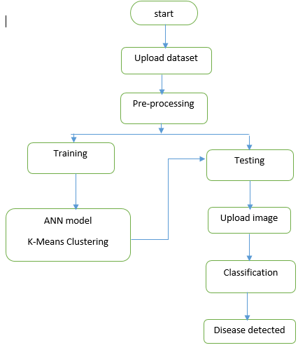

**HARDWARE & SOFTWARE REQUIREMENTS**

# H/W Configuration:

# Processor - I3/Intel Processor

* Hard Disk -160GB
* Key Board - Standard Windows Keyboard
* Mouse - Two or Three Button Mouse
* Monitor - SVGA
* RAM - 8Gb

**S/W Configuration:**

* Operating System : Windows 7/8/10
* Server side Script : Python, Anaconda
* IDE : Pycharm
* Libraries Used : Numpy, IO, OS, Flask, keras,
* Technology : Python 3.6+

**Stake Holders:**

* Formers.
* Agricultural Agencies.
* Fruit sellers.
* Customers/consumers.